Tien Ho

Time Series Analysis

**Part 1: Detrend the entire data set using a linear model**

1) y = mauna_loa$interpolated

x = 1:length(y)

2) plot.ts(y)

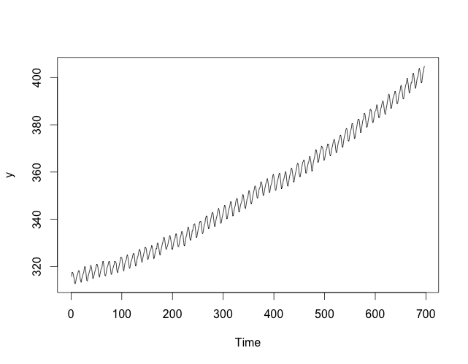

3) fit1 = lm(y~x)

4) abline(fit1, col=”red”)

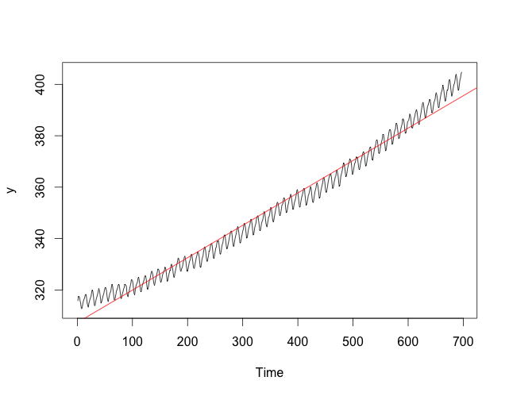

5) detrendedY = y - fitted(fit1)

6) plot.ts(detrendedY)

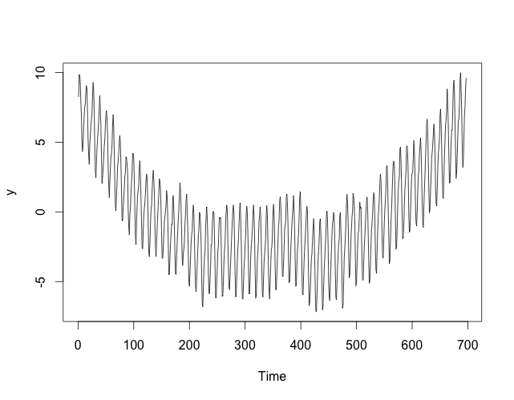

**Part 2: Detrend a subset of the data in the range 203:394**

1) y = mauna_loa$interpolated[203:394]

x = 1:length(y)

2) fit2 = lm(y~x)

3) plot.ts(y)

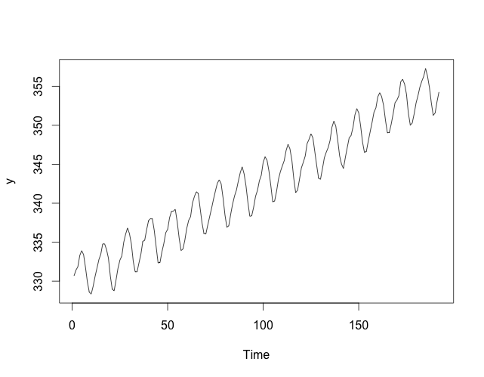

4) abline(fit2, col=”red”)

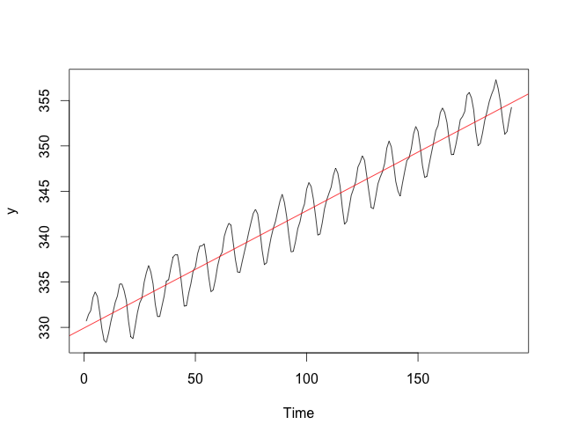

5) detrendedY = y - fitted(fit2)

plot.ts(detrendedY)

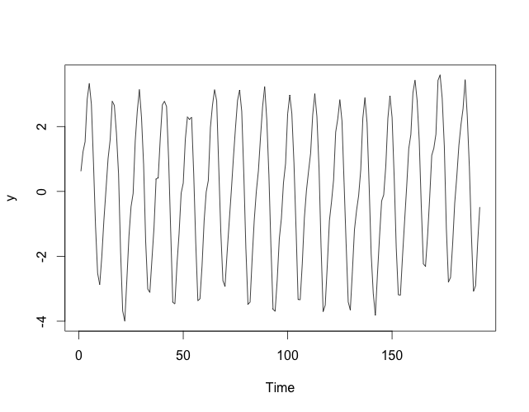

**Part 3: Remove the cyclic component by subtracting monthly average**

1) monthlyAverage = function(detrendedY, month) {

observations = which(mauna_loa$Month == month)

tmp = which(observations >= 203 & observations <= 394)

observations = observations[tmp] - 202

monthly_values = detrendedY[observations]

return (sum(monthly_values) / length(observations))

}

2) deCycle = function(detrendedY) {

results = c()

for (i in 1:12) {

monthly_average = monthlyAverage(detrendedY, i)

results = c(results, monthly_average)

}

return (results)

}

3) plot.ts(detrendedY)

4) decycledY = deCycle(detrendedY)

5) interval = seq(from=1, to=length(y), by=16)

points(interval, decycledY, col=”red”)

lines(interval, decycledY, col=”red”)

